Congregation Beth Abraham Book Club
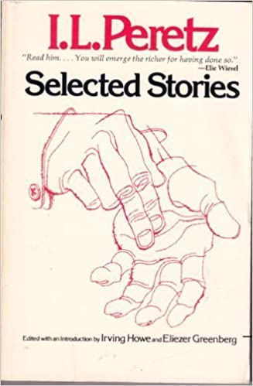

Here is a summary of Selected Stories excerpted from Pakn Treger:
The third of the great triumvirate of classic Yiddish writers, along with S.Y. Abramovitz and Sholom Aleichem, Peretz was the one who truly brought European literary tradition into Yiddish literature. His stories range widely in genre from biting social satire to reworking of folkoric and Hasidic tales to modernist masterpieces as well as intensely realisltic memoirs and travel descriptions.
If you want to be a part of this discussion, contact Shelly at info@congregationbethabraham.net , so she can send you a link before the meeting.

